Inkwell Insights : A Blogging Website

Web Technology (IT254) Course Project

### Submitted in partial fulfillment of the requirements for the degree of

### BACHELOR OF TECHNOLOGY

### In

### INFORMATION TECHNOLOGY

### by

### NITHIN S 221IT085

AYUSH KUMAR 221IT015

JAY CHAVAN 221IT020



### DEPARTMENT OF INFORMATION TECHNOLOGY NATIONAL INSTITUTE OF TECHNOLOGY KARNATAKA SURATHKAL, MANGALORE -575025

### March, 2024

**D E C L A R A T I O N**

We hereby *declare* that the *OS Project Report* entitled **“Inkwell Insights : A Blogging Website”** which is being submitted to the National Institute of Technology Karnataka Surathkal, in partial fulfillment of the requirements for the award of the Degree of Bachelor of Technology in the Department of Information Technology, is a ***bonafide report of the work carried out by us.*** The material contained in this project report has not been submitted to any University or Institution for the award of any degree.

Nithin S Ayush Kumar Jay Chavan

Signature Signature Signature

Department of IT Department of IT Department of IT

Place : NITK, SURATHKAL

Date : 26 March 2024

**CERTIFICATE**

This is to certify that the Seminar entitled **“Inkwell Insights : A Blogging Website”** has been presented by Nithin S (221IT085), Ayush Kumar (221IT015) & Jay Chavan ( 221IT020), students of IV semester B.Tech.(I.T), Department of Information Technology, National Institute of Technology Karnataka, Surathkal, on 26 March, 2024, during the even semester of the academic year 2023 - 2024, in partial fulfillment of the requirements for the award of the degree of Bachelor of Technology in Information Technology.

Examiner-1 Name Examiner-2 Name

Signature of the Examiner-1 with Date Signature of the Examiner-2 with Date

Place: Date:

**ABSTRACT**

In the modern digital age, blogging has evolved into a powerful medium for individuals to share their ideas, experiences, and expertise with a global audience. To cater to this growing trend and provide users with a seamless and robust platform for expression, interaction, and exploration, we propose the development of a MERN Stack Blogging Website.This project aims to leverage the capabilities of the MERN (MongoDB, Express.js, React.js, Node.js) stack, coupled with Tailwind CSS for responsive and visually appealing UI design. The core functionalities of the website will revolve around advanced authentication mechanisms, ensuring secure user interactions and data privacy. By combining the flexibility and scalability of the MERN stack with advanced authentication mechanisms and user-centric features, the proposed blogging website aims to provide users with a comprehensive platform for sharing, exploring, and engaging with diverse content in a secure and interactive manner.

**TABLE OF CONTENTS**

**CHAPTER 1: INTRODUCTION 1**

**CHAPTER 2: OBJECTIVE** **2**

**CHAPTER 3: METHODOLOGY** **3**

Code Structure3

**CHAPTER 4: SYSTEM DESIGN 4**

Block Diagram4

**CHAPTER 5: IMPLEMENTATION****6**

**CHAPTER 6: CONCLUSION 7**

Result7

Future Scope 8

References 9

**LIST OF FIGURES**

#### 

#### Figure 4.1: Flowchart of Website Architecture 4

#### Figure 4.2: Frameworks used 5

Figure 6.1: Front Page & Post Page 14

Figure 6.2: Admin Dashboard & Profile Page 15

# CHAPTER 1: INTRODUCTION

The digital era has ushered in a new age of connectivity and expression, where individuals seek platforms to share their thoughts, experiences, and expertise with a global audience. In response to this evolving landscape, the development of a MERN (MongoDB, Express.js, React.js, Node.js) Stack Blogging Website emerges as a pertinent solution. This project aims to provide users with a versatile and robust platform to engage in online journaling and content sharing, fostering meaningful interactions and discussions across diverse topics. The MERN Stack Blogging Website will leverage the power of React.js for building dynamic and interactive user interfaces, complemented by the flexibility and responsiveness of Tailwind CSS for modern UI design. Central to the project's architecture is the implementation of advanced authentication mechanisms to ensure user privacy and security, enabling seamless registration, login, and account management processes. Key features of the proposed website include advanced search functionality, facilitating the discovery of relevant content based on keywords, categories, or tags. Additionally, the platform will support features like commenting, allowing users to engage in discussions and provide feedback on posts. By integrating these functionalities and prioritizing user experience, the MERN Stack Blogging Website aims to provide a comprehensive and engaging platform for individuals to share their perspectives, connect with like-minded individuals, and contribute to a vibrant online community of knowledge sharing and exchange.

In summary it’s a MERN Stack project leveraging Tailwind CSS, Flowbite, GoogleAuthentication through Firebase and Redux Toolkit. It has various features like role based views, search & sort, light & dark mode and so on.

# CHAPTER 2: OBJECTIVE

The objective of this project is to develop a modern and feature-rich MERN (MongoDB, Express.js, React.js, Node.js) stack blogging website that serves as an engaging platform for both content creators and consumers. The primary goal is to create an interactive and user-friendly environment where individuals can share their thoughts, experiences, ideas, and expertise on various topics, fostering meaningful interactions and discussions.

Key objectives of the project include:

* Creating a dynamic and visually appealing user interface using React.js and Tailwind CSS to enhance user engagement and experience.
* Implementing advanced authentication mechanisms to ensure secure user registration, login, and account management, prioritizing user privacy and data security.
* Enabling content creators to publish blog posts with rich text editing capabilities, multimedia support, and customizable layouts for an immersive storytelling experience.
* Facilitating user interaction through features like commenting, liking, and sharing posts, encouraging community engagement and collaboration.
* Incorporating advanced search functionality to enable users to discover relevant content based on keywords, categories, or tags, enhancing content discoverability.
* Implementing responsive design principles to ensure seamless usability across various devices and screen sizes, catering to a diverse audience.
* Prioritizing performance optimization and scalability to accommodate a growing user base and increasing content volume without compromising on speed and responsiveness.
* Conducting rigorous testing and quality assurance measures to identify and address any bugs or usability issues, ensuring a smooth and error-free user experience.
* Providing comprehensive documentation and user guides to assist both content creators and consumers in navigating the platform effectively and maximizing its potential.

Overall, the project aims to deliver a cutting-edge MERN stack blogging website that not only meets the needs and expectations of modern content creators and consumers but also promotes interaction, collaboration, and engagement within a vibrant online community.

# CHAPTER 3: METHODOLOGY

Based on the provided information, the project scope entails developing a MERN stack blogging website with modern features and robust functionality. The primary objectives include creating an engaging platform for content creators and consumers, fostering interaction and user engagement, and implementing all modern features to enrich the user experience.

Key features and functionalities of the proposed MERN stack blogging website include:

* **User Authentication** : Implementation of advanced authentication mechanisms such as JWT (JSON Web Tokens) and Google OAuth to ensure secure user registration, login, and account management.
* **Admin Management** : Integration of admin functionality to oversee and manage the blog, including the ability to verify posts, manage categories, and handle user accounts.
* **Content Creation and Management** : Enable users to create, edit, and delete blog posts, with the option for admins to review and approve posts before publication. Posts can be categorized for better organization and searchability.
* **User Interaction** : Implementation of features such as liking, commenting, and sharing posts to encourage user engagement and community building.
* **Responsive Design** : Development of a fully responsive website compatible with various devices, including PCs, tablets, and mobile devices, to ensure optimal user experience across platforms.
* **Light and Dark Mode** : Integration of light and dark mode themes to provide users with customizable viewing options for improved readability and aesthetics.
* **Search and Sort Functionality** : Implementation of search and sorting features to allow users to easily find relevant content based on keywords, categories, or tags.
* **CRUD Operations** : Implementation of CRUD (Create, Read, Update, Delete) operations for managing blog posts and other content, ensuring efficient data management and organization.
* **Optimization and Debugging** : Optimization of code and debugging to enhance website performance, responsiveness, and overall user experience.
* **Integration with Redux Toolkit** : Utilization of Redux Toolkit for state management to streamline data flow and improve application performance.

**CHAPTER 4: SYSTEM DESIGN**

## Block Diagram

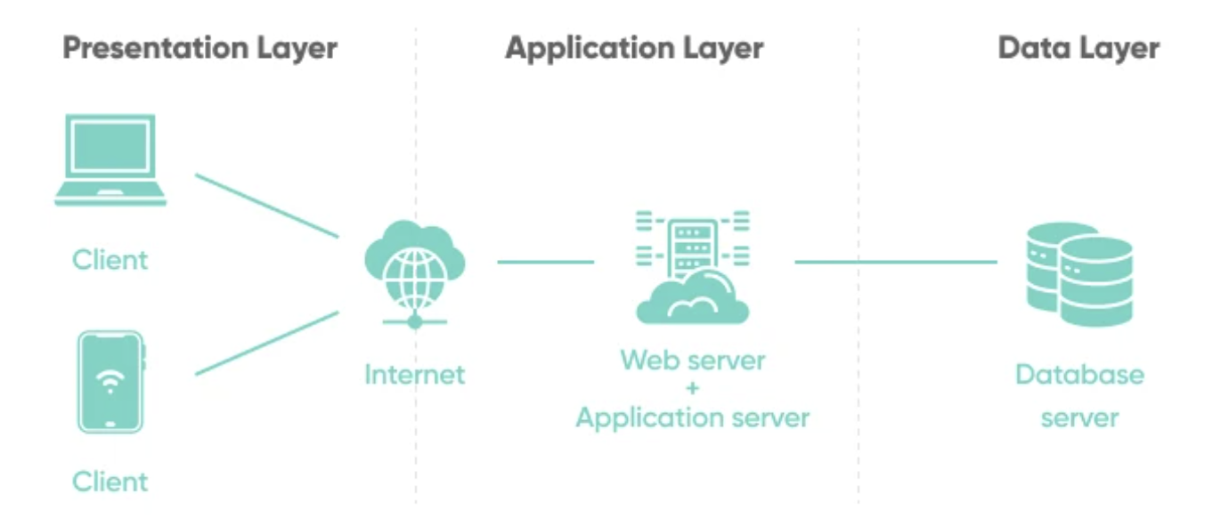

*Figure 4.1: Website Architecture*

The MERN stack blogging website follows a modern and scalable architecture designed to handle various components and interactions efficiently. At its core, the architecture consists of four main layers:

**Presentation Layer** : This layer represents the user interface (UI) of the website, built using React.js and Tailwind CSS. It includes components for rendering blog posts, comments, user profiles, and navigation menus. The UI layer is responsible for presenting information to users and handling user interactions.

**Application Layer** : The application layer contains the business logic of the website, implemented using Node.js and Express.js on the backend. It handles requests from the frontend, processes data, interacts with the database, and manages authentication and authorization. This layer ensures the functionality and security of the website's features, such as user authentication, blog post management, and comment moderation.

**Data Layer** : The data layer consists of the MongoDB database, which stores all website data, including user accounts, blog posts, comments, categories, and settings. MongoDB's flexible document-oriented model allows for efficient storage and retrieval of structured and unstructured data. This layer is responsible for managing data persistence and ensuring data integrity.

**Infrastructure Layer** : The infrastructure layer comprises the underlying infrastructure components required to deploy and run the website, such as hosting servers, cloud services, and networking configurations. It ensures the availability, scalability, and performance of the website by managing resources, monitoring system health, and handling traffic distribution.

Overall, the architecture of the MERN stack blogging website is designed to be modular, scalable, and maintainable, allowing for easy expansion and customization as the website grows and evolves. Each layer performs specific functions and communicates with other layers through well-defined interfaces, enabling efficient development, deployment, and management of the website.

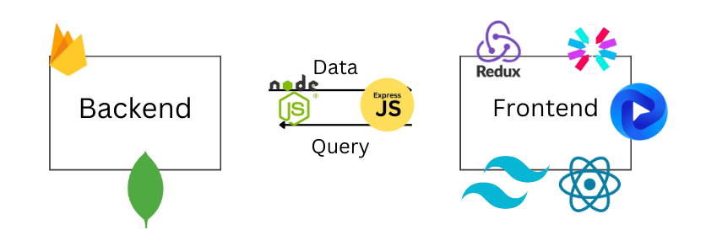

*Figure 4.2: Frameworks Used*

**Frontend**: ReactJS, TailwindCSS, Flowbite

**ODM**: Mongoose

**Backend**: ExpressJS, MongoDB, Firebase

**Misc**: React Redux Toolkit, JSON Web Tokens, React Quill, Moment, Nodemon, Cookie Parser, BcryptJS, Dotenv

**CHAPTER 5: IMPLEMENTATION**

**MongoDB** : We have used this NOSQL database to store user names, posts and comments

**Firebase**: We have used this cloud database to store user profile images, post images and all visual data

**ExpressJS**: Express.js is employed for building the backend server of the application. It simplifies the process of handling HTTP requests, routing, and middleware integration.

**ReactJS**: React is used for building the frontend of the blogging website. It allows for efficient rendering of user interfaces, component reusability, and state management.

**TailwindCSS**: TailwindCSS is utilized for styling the frontend components. It provides utility-first CSS classes for quickly building custom designs.

**Redux Toolkit** : Redux is used for state management in the React application. It helps manage complex application states efficiently across different components.

**JSON Web Tokens** : JWT is used for generating and verifying authentication tokens. It ensures secure communication between the client and server by encoding user information.

**React Quill** : React Quill is a rich text editor component used for creating and editing blog posts. It offers a user-friendly interface for formatting text content.

**Moment:** Moment.js is employed for parsing, validating, manipulating, and formatting dates and times in JavaScript. It enhances the user experience by providing accurate and customizable date-time functionalities.

**Nodemon** : Nodemon is a utility that monitors changes in the server-side code and automatically restarts the server. It aids in the development process by reducing the need for manual server restarts.

The project begins by setting up the development environment with React.js and Tailwind CSS, creating basic UI components such as the header and footer. React Router Dom is then integrated for seamless navigation between different pages of the website. Next, authentication mechanisms are implemented using JWT (JSON Web Tokens) and Google OAuth, allowing users to sign in, sign up, and sign out securely. Redux Toolkit is employed for state management, ensuring efficient handling of application state across components.

The backend is set up using Node.js and Express.js, with MongoDB serving as the database solution. CRUD (Create, Read, Update, Delete) operations are implemented to manage blog posts, categories, and user accounts securely. Backend routes are secured to prevent unauthorized access and ensure data integrity. Advanced functionalities such as search and sort functionality, comment system, and dark mode are integrated to enhance user experience and engagement. The website is optimized for responsiveness and compatibility with various devices, including PCs, tablets, and mobile devices.

Additionally, different views are implemented for registered users, unregistered users, and blog admins, each tailored to their specific needs and permissions. Admin dashboard functionalities enable admins to manage blog posts, users, and site settings efficiently. Throughout the implementation process, attention is given to optimizing performance, debugging any issues, and ensuring the overall robustness and reliability of the MERN stack blogging website. Regular testing and quality assurance measures are conducted to identify and address any bugs or usability issues, ensuring a seamless user experience.

**CHAPTER 6: CONCLUSION**

## RESULTS

## 

## In conclusion, the MERN Stack Blogging Website has successfully created an engaging platform for content creators and consumers. Leveraging modern technologies like React.js and Tailwind CSS, along with advanced authentication mechanisms, we've developed a responsive interface fostering interaction and community building.

## 

## Key features including Google OAuth integration, user-specific views, search and sort functionality, and a robust comment system enhance user experience and promote engagement. Additionally, light and dark mode options, coupled with device optimization, ensure accessibility across diverse user preferences.

## 

## Overall, the website stands as a testament to the significance of content diversity and audience engagement in today's digital landscape, providing a versatile platform for personal expression and community building.

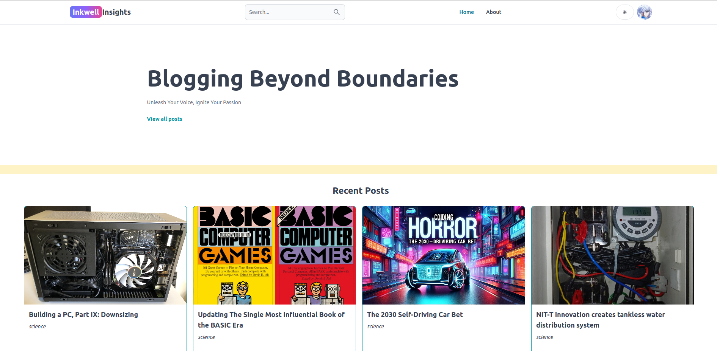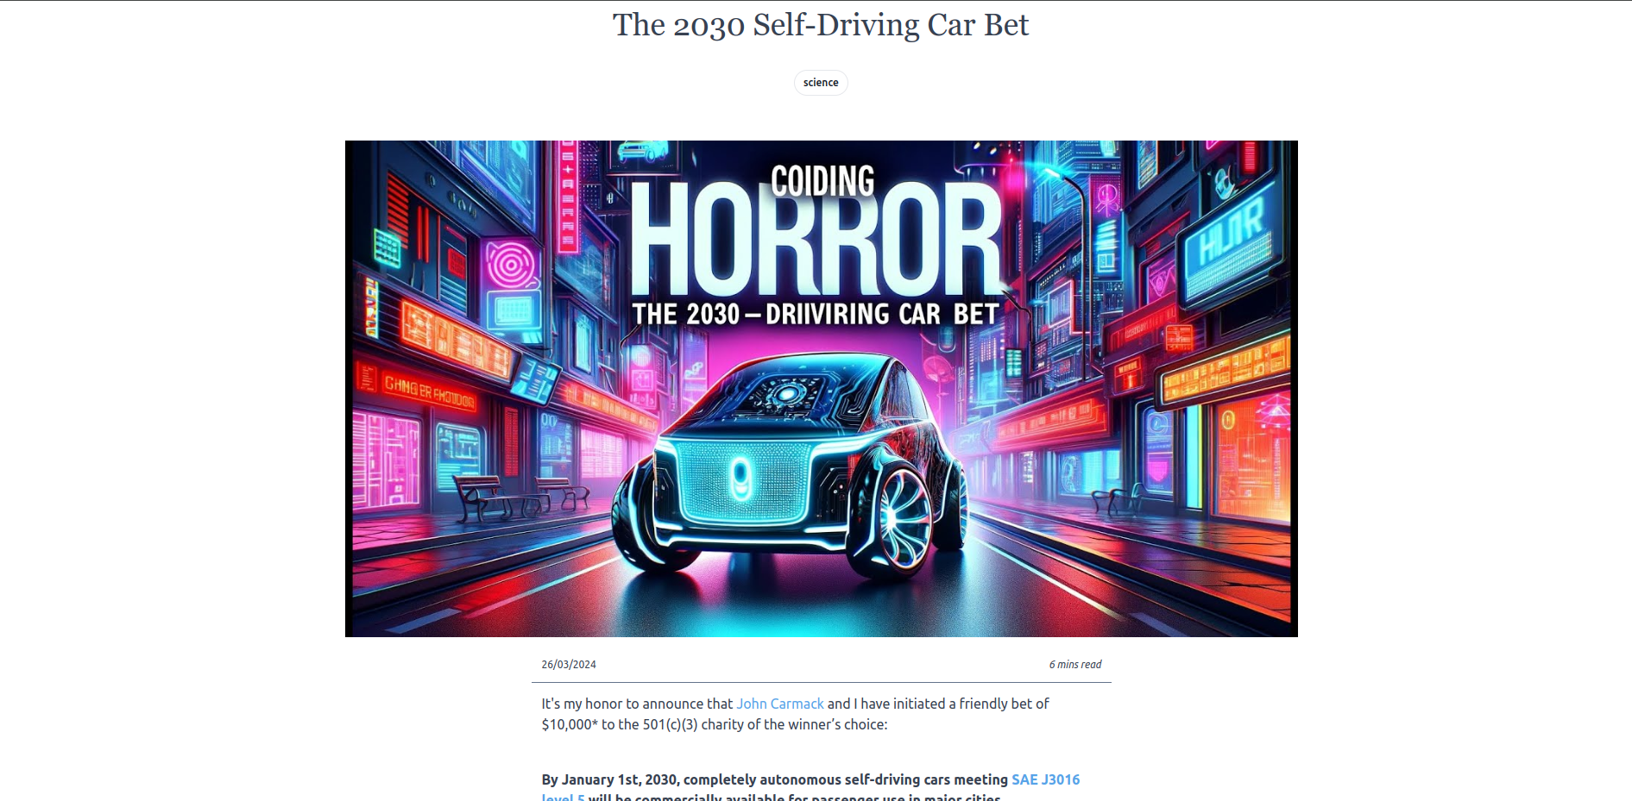

*Figure 6.1: Front Page and Post Page*

## 

## 

## 

## 

*Figure 6.2: Admin Dashboard & Profile Page*

## 

## FUTURE WORK

**Enhanced User Profiles** : Implement features to allow users to customize their profiles, including profile pictures, bios, and social media links.

**Hosting the Website**: Our main goal would be to host the made website into a domain and allow pubic

users can access it.

**Advanced Analytics** : Integrate analytics tools to provide users and admins with insights into post performance, user engagement metrics, and audience demographics.

**Content Recommendation** : Implement algorithms to suggest personalized content recommendations based on user preferences, browsing history, and interactions.

**Collaborative Editing** : Enable collaborative editing and drafting of blog posts, allowing multiple users to contribute and edit content collaboratively.

**Monetization Options** : Explore opportunities for monetization, such as advertising, sponsored content, premium subscriptions, or affiliate marketing, to support content creators and generate revenue.

**Localization and Internationalization** : Expand the platform's reach by implementing support for multiple languages and cultural preferences, catering to a global audience.

**Community Moderation Tool**s : Develop tools and features to empower the community to self-moderate content, flag inappropriate posts/comments, and enforce community guidelines.

**Integration with External Platforms** : Integrate with external platforms such as social media networks, content syndication platforms, or publishing tools to expand the reach and visibility of blog content.

**Accessibility Improvements** : Conduct accessibility audits and implement improvements to ensure the platform is accessible to users with disabilities, adhering to WCAG guidelines.

**Continuous Performance Optimization** : Continuously optimize the platform's performance, scalability, and security through regular audits, updates, and enhancements to maintain a seamless user experience and mitigate potential vulnerabilities.

## REFERENCES

J. L. Herrero, F. Lucio and P. Carmona, "Web services and web components," 2011 7th International Conference on Next Generation Web Services Practices, Salamanca, Spain, 2011, pp. 164-169, doi: 10.1109/NWeSP.2011.6088171. keywords: {Servers;Browsers;Web services;Computers;Europe;Software as a service;Web services;web application;component-based development;RIA},

S. R. Kumar, R. Sharma and K. Gupta, "Strategies for web application development methodologies," 2016 International Conference on Computing, Communication and Automation (ICCCA), Greater Noida, India, 2016, pp. 160-165, doi: 10.1109/CCAA.2016.7813710. keywords: {Object oriented modeling;Unified modeling language;Programming;Software;Computer architecture;Servers;XML;XP (Extreme Programming);WCML (Web Mark Up Language);CORBA (Common Object Request Broker Architecture);AWDWF (Agile Web Development with Web Framework)},

X. Li and J. A. Chishti, "The impact of emerging website design features," 2017 4th International Conference on Systems and Informatics (ICSAI), Hangzhou, China, 2017, pp. 1657-1662, doi: 10.1109/ICSAI.2017.8248550. keywords: {Testing;Usability;Libraries;Loading;Shape;Browsers;Tools;Emerging website design features;influence;accessibility;performance},

S. Otsuka, K. Kato and V. Klyuev, "Academic laboratory website development," 2015 17th International Conference on Advanced Communication Technology (ICACT), PyeongChang, Korea (South), 2015, pp. 791-794, doi: 10.1109/ICACT.2015.7224903. keywords: {Servers;Radiation detectors;Switches;Computers;Smart phones;Internet;Website Development;Responsive Web Design},